
The Whole Earth land sea and air and everything else now under Jurisdiction of God Almighty
Love your Creator God, Love your neighbour as yourself and do unto others as you would have them do unto you and;
Thou shall not steal, thou shall not bear false witness

NZ Registered Mail Tracking Number:

7th day of September in the year of our Lord 2026

Address for service:
living Man Lucas Michael of the House of Kujawa
Care of 12824 Pheasant Run, Burnsville, MN 55337

To:
As agent for:
Address:

Notice of Affidavit of Standing of Lucas Michael of the House of Kujawa and Claim on Land of Substance and Trespass Notice

This is a self-executing claim and declaration

Notice Principal to Principal
Notice to Agent is Notice to Principal and Successors
Notice to Principal and Successors is Notice to Agent

For context, this Notice and Affidavit of Claim uses only plain simple English and Counting Systems. You are considered informed that all meanings in this communication are taken from the Oxford Dictionary of English 2024 edition unless otherwise definition given or as commonly comprehended by living men and women. Any content or character or page layout is not to be confused with legalese or any other language. If any definition or meaning is unclear to the reader the interpretations are that of the living man author of this affidavit. The position in this communication is that of a living man standing under God’s law, also known as the creator’s law, natural law, and operating outside the jurisdiction of statutory rules or man-made legislation.
Allodium: Freehold estate; land which is the absolute property of the owner; real estate held in absolute independence, without being subject to any rent, service, or acknowledgment to a superior. It is thus opposed to feud.
This document is presented for the reader’s benefit with honourable and peaceful intent to provide the reader with notice that the jurisdiction of the Council and the Crown corporation have been removed from the land known 12824 Pheasant Run, Burnsville, MN 55337 This notice has also been placed on the public notice board publicnoticesnz.com

- I, the Living Soul Author and Principal Lucas Michael notify the reader that I have an Affidavit of Standing and Life which is also on the public notice board publicnoticesnz.com and both can be found under category of unrebutted affidavits, where the author Lucas Michael holds the original documents; and

- Corporation Law over my life and name titles and over my property has been removed, and my property and estate returned to me as the executor and beneficial owner and ‘secured party’ and ‘creditor’ but not surety to any corporation or corporate agent as debtor of all trade names and entities that have been set up to represent me; and
- I, Living Soul Author and Principal Lucas Michael declare that I am a living breathing man who is alive and well and able to manage my own affairs, self-determine, and administer my own estate and declare that I am not Crown property or a subsidiary company to any of the Crown Companies and are therefore not subject to Crown Law, but only the lore of Nature and law of God; and anyone taking authority over a living man or woman without his or her consent is committing the crime of slavery and I state clearly that I have never consented to anyone have control or authority over me; and

- I Living Soul Author and Principal Lucas Michael of the house of Kujawa claim my independence and restoration of all rights back to the commencement of my life and the age of majority; and as of the date known as 7th day of the month of September in the year two thousand and twenty-six [2026]; and I living man Lucas Michael do hereby claim and declare that the land of substance and all the resources, living and otherwise thereon, commonly known as 12824 Pheasant Run, Burnsville, MN 55337 identified on ‘Exhibit A’ by the outlines, are henceforth considered to be held in allodium by I living man Lucas Michael and from herein any and all parts of this claim all references to land/this land/these lands means the land of substance commonly known as 12824 Pheasant Run, Burnsville, MN 55337 identified on ‘Exhibit A’ by the outlines; and

- I Living Soul Author and Principal Lucas Michael have absolute allodium property right and not a mere estate and claim and declare supreme authority over these lands using God’s Law, Natural Law and Genesis 1:26-28 “v26 Then God said, “Let Us make man in Our image, according to Our likeness; let them have dominion over the fish of the sea, over the birds of the air, and over the cattle, over all the earth and over every creeping thing that creeps on the earth.” v27 So God created man in His own image; in the image of God He created him; male and female He created them. 28 Then God blessed them, and God said to them, “Be fruitful and multiply; fill the earth and subdue it; have dominion over the fish of the sea, over the birds of the air, and over every living thing that moves on the earth.” ; and therefore this land is freely held and occupied by living men and women without obligation or service or fee to any overlord or landlord or government or local authority; and

- I, Living Soul Author Lucas Michael hold no contract with any de facto occupying corporate Aotearoa and/or Nu Tireni and/or UNITED STATES et al government for their public debts or commercial liabilities at any time whatsoever; and

- I, Living Soul Author Lucas Michael declare that the one true almighty God created men and woman, and men and woman created corporations; and a corporation can never have control or authority over a living man or woman without their consent and I have not consented to any corporation having control or authority over me; and

- I, Living Soul Author Lucas Michael am neither a thing, nor discounted entity, nor legally defined person, nor human-being, nor individual, nor resident, nor ratepayer, nor rating unit or withholding agent, as these terms are defined under the Statute of which “we the people have not consented to,” and as such, I am henceforth to be recognised as a living breathing soul, living on the land under Almighty God; and are no longer ‘lost at sea’; and

- from age of consent to the date of this Affidavit, I, living soul author Lucas Michael have never signed any contract knowingly, willingly, intelligently, voluntarily, or intentionally whereby I have waived any of my natural inherent rights. I hereby revoke, rescind, cancel, and make void all ‘contracts’, ‘agreements’, ‘forms’, or ‘instruments’ that I have signed as individual, director, trustee, trustee director or as guarantor or any other capacity and that have been, are being, or may potentially be construed to give the agent(s) of any agency or department of any ‘incorporated government’, any ‘banking corporation’, any ‘authority’, ‘venue’, or ‘jurisdiction’ over I, living soul author Lucas Michael where such unacceptable ‘contracts,’ ‘agreements,’ and ‘forms’ that exist to exploit me have been proven to be grammatically fraudulent and are therefore to be considered null and void from the legal and lawful viewpoints of all parties involved; and

- I, Living Soul Author Lucas Michael rescind and revoke all prior assumed and presumed Powers of Attorney and authority taken using fraud and without full disclosure or my full knowledge or consent, and fully claim back my own power of attorney over my own life plus over the names and legal titles and trade names that have been used to represent me such as LUCAS M. KUJAWA© or LUCAS KUJAWA© or LUKE KUJAWA© or LUCAS MICHAEL KUJAWA©; KUJAWA, L.M.; MR L.M. KUJAWA and all other variations or abbreviations; and

- I, Living Soul Author Lucas Michael by means of this Living Testimony declare that I am the Secured Party and Creditor and not the Debtor of all my assigned names as the beneficial owner and true heir and executor of the estates of all relevant assumed and presumed Trade Name(s), These Trade Name(s) include, but are not limited to, LUCAS KUJAWA© or LUKE KUJAWA© or LUCAS MICHAEL KUJAWA© or LUCAS M. KUJAWA©; KUJAWA, L.M.; MR. L.M. KUJAWA and all other variations or abbreviations however styled, punctuated, spelled, ordered, or otherwise represented as numbers or symbols to represent these trade names including any type of military titles as pertaining to me and my estate. I, Living Soul Author Lucas Michael make no ghastly claim(s) to any type of Military Titles. All derivatives, variations, punctuations, and orderings of these names are not acting in any federal territorial or municipal capacity and have not knowingly or willingly acted in any such capacity since the day of nativity; and

- I, Living Soul Author Lucas Michael with full authority as the living Secured Party Creditor and Power of Attorney and Executor and Beneficial Owner of the estates hold all trade names and entities set up to represent me harmless and indemnified of all debts associated with LUKE KUJAWA© or LUCAS KUJAWA© or LUCAS MICHAEL KUJAWA© or LUCAS M. KUJAWA©; KUJAWA, L.M.; MR. L.M. KUJAWA and all other variations or abbreviations however styled, punctuated, spelled, ordered, or otherwise represented as numbers or symbols to represent these trade names including any type of military titles as pertaining to me and my estate; and

- the allodial designation over this physical land commonly known as 12824 Pheasant Run, Burnsville, MN 55337 is established through careful observation and consideration of the following facts:

13.a. I, Living Soul Author and Principal Lucas Michael am a live, sovereign, living, breathing sentient being with soul, spirit, breath, conscience and competence and not a dead fictitious entity; and

13.b. I, Living Soul Author and Principal
Lucas Michael as a living man and having come of age have supreme authority over any and all corporate entities; and

13.c. that the land that I Living Soul Author and Principal Lucas Michael are living on is not artificial as it has physical substance; and

13.d. I, Living Soul Author and Principal Lucas Kujawa and other living men and women gain life, sustenance, and shelter from and upon the physical land and gardens, see Exhibits A and B, that have been established since purchasing the land in the year commonly known as two thousand and twenty six]; and

13.e. physical land is real, whereas a non-physical corporation cannot own anything of physical substance and therefore the Crown and the New Zealand Government et al as corporate entities cannot own land of substance and use artificial construct of legal titles and registration to claim control and ownership of something of physical substance; and this is misleading and therefore fraud has been detected; and

13.f. as fraud is identified this renders the legal title contract/s a null and void in their entirety, as the Crown and New Zealand Government et al are companies and bound by contract Law; and

13.g. the legal title and registers held by the Crown and New Zealand Government et al to make a claim upon this land is now established as fraudulent; and

13.h. all jurisdiction of the Crown and any of its corporations such as “STATE OF MINNESOTA,” “UNITED STATES OF AMERICA” Local Government Funding Agency and Bay of Plenty Local Authority Shared Services and, The First District Court Of Minnesota, District Council and, Regional Council, and all other districts and claimed authorities claiming to adjudicate law/commerce in any land under maritime, UCC, commercial, etc is removed of this land including any monetary charges, with any further charges sent without my written consent liable for charges in my compensation schedule attached as ‘Exhibit ‘C’ and

13.i. no corporate entity or their agents have any jurisdiction to administer the affairs of, enter, obstruct, harm or injure et al on this physical land nor cause harm to nor claim ownership over, any physical land, resources, living man or woman, animal, water, air, soil, flora and fauna in their entirety; and

13.j. as this land is now under Jurisdiction of Almighty God, of love God, love our neighbour as ourself and do no harm, it is not subject to any man made act, and according to Genesis 1:26-30 I have dominion over the earth and can build and manage the resources on this land the way I see fit as long as no harm is being done to any living sentient beings or other living creatures, with the intent to find ways to add to the earth and its resources rather than deplete them; and

- I, Living Soul Author Lucas Kujawa declare that if anyone acts in bad faith towards me, tries to deceive me with intent to harm me or tries to enslave me they have committed crimes of slavery and fraud and I have the lawful right and authority to charge them fees according to my compensation charge fee schedule in Exhibit ‘C’ which can also change and be updated without notice; and once I serve notice to the guilty party they have ten working days to pay in full and if not paid by that date they are considered in default and I have the right to claim ownership and seize any assets or property owned by the guilty party or agent acting on behalf of the guilty party, and if the guilty party shows remorse I can choose whether to give them a remedy in replace of the owed debt, but if the guilty party does not follow through with actions requested in the remedy I have the right to continue with claiming ownership of the assets belonging to the guilty party; and

Notice Of Liability:

- all government/corporate entities and all claimed jurisdiction, authority and administration are removed in relation to the affairs of living soul author and Principal Lucas Michael and the land of physical substance commonly known as 12824 Pheasant Run, Burnsville, MN 55337] identified on ‘Exhibit A’ by the outlines, and all resources upon it in the entirety absolute; and

- I, Living Soul Author and Principal Lucas Michael hold these lands in allodium and live on and care for this land and will continue to maintain it with the utmost care and consideration and intend to live a quiet peaceful life in the private working in harmony with nature; and

- That Lucas Michael of the House of Kujawa and Johnson has already taken his allodial claims and had them unrebutted in the High Court of the United States by the Crown Corporations, the Council Corporations, District Courts, Freddie Mac &Fannie Mae as they could not rebut the truth that physical land is real, whereas a non-physical corporation cannot own anything of physical substance and therefore the Crown and the United States Government et al as corporate entities cannot own land of substance and use artificial construct of legal titles and registration to claim control and ownership of something of physical substance; this is misleading and therefore fraud has been detected; and as fraud is identified this renders the legal title contract/s null and void in their entirety, as the Crown and United States Government et al are companies and bound by contract Law; and the legal title and registers held by the Crown and United States Government et al to make a claim upon this land is now established as fraudulent; and all jurisdiction of the Crown and any of its companies including United States Local Government Funding Agency Limited plus all Crown Corporations plus all Council Corporations plus all Bank corporations have been removed over all land where Janine (case found in New Zealand) obtained Summary Judgement in the High Court against all the Corporations removing their authority over all land and all individuals living and breathing men, women, boys and girls so all that individuals need to do is step in and claim back his/her authority as a living breathing sentient being created by God where no corporation can have control over a living man or woman without his/her consent and Janine’s summary judgments against these corporations stand as truth in law and commerce can also be found on the public notice board publicnoticesnz.com; and

- That I Lucas Michael provide all readers and defendants listed at the top of affidavit as representatives of The First District Court of Minnesota & it’s agent’s clerk’s, admin & all form of staff, Joe Leko (Sheriff of Dakota County, MN), Freddie Mac & Fannie Mae & it’s agents, Federal Judicial Councils & their agents, The U.S. Congress & it’s agent’s, The office of the President & it’s agent’s, The Minnesota State Comission on Judicial Conduct & it’s agent’s, The Department of Justice & it’s agents ten working days from receipt to rebut point by point in their full commercial capacity and signed with their wet ink signature where non response from the readers and defendants confirms the following facts regarding the mortgage and loan agreement that was made associated with me and my property:
18a. That a loan agreement with Mortgage Electronic Registration Systems, Inc., as nominee form United wholesale Mortgage, LLC was signed on September 9th, 2022, document # 3676779, for, $351,140.00 by me however it was never co-signed by a representative of United Wholesale Mortgage LLC and its officers and representatives have never been able to produce the loan agreement showing it was signed by both parties, where this makes the contract null and void in its entirety therefore United Wholesale Mortgage LLC (Assigned to TH MSR Holdings LLC on, May 22, 2025) and its officers and representatives have committed fraud and are required by law to immediately pay me back all funds and interest paid since this time and cancel this loan and mortgage in full and remove any registered interest on the title of this property; and
18b. That United Wholesale Mortgage LLC (TH MSR Holdings LLC) and its officers and representatives created funds that did not exist prior from my wet ink signature on the loan agreement and committed fraud, where non response from the readers and defendants confirms that United Wholesale Mortgage LLC (TH MSR Holdings LLC) did not lend anything of substance and is therefore making fraudulent charges to me for repayment of any funds or interest charges; and, furthermore, the fraudulent ensuing attempt to evict (by Judicial Officer, Matthew Schmidt of The First District Court of MN) through wrongful foreclosure, and an abhorrent conduct of “court”, which was never proven jurisdictionally through oath’s and bonds necessary to conduct court, with a claim being made to be a “Judge” without proper identification, as well, failed to provide due process while infringing on the 1st Constitutional right while attempting to force eviction proceedings without any contract to do so.
18c. That United Wholesale Mortgage LLC (TH MSR Holdings LLC) and its agents and representatives did not inform me in writing exactly what property of mine they took security over to obtain the mortgage where full disclosure is required for an agreement to be lawful and if full disclosure not provided the agreement becomes null and void; and
18d. That United Wholesale Mortgage LLC (TH MSR Holdings LLC) and its agents and representatives sold on the loan document with my wet ink signature onto to other party(s) without my consent or knowledge which also makes the agreement null and void; and
18e That United Wholesale Mortgage LLC (TH MSR Holdings LLC) and its agents and representatives received payment in full at the time the loan(s) were granted, and therefore there was never any money owing and all charges from that time are fraudulent; and
18f. That any officer or representative of United Wholesale Mortgage LLC (TH MSR Holdings LLC) that tries to claim interest or charges from me or the bank account that I am holder on are actively participating in fraud and can be charged with crimes of fraud plus I can charge one million dollars per event of withdrawal of any funds from the bank account that I hold in trust that each of the individuals named in this document can be charged and now being fully aware of the fraud and therefore fully liable in the private for not stopping the fraudulent charges; and
18g. That according to The Mortgage (death contract) document dated, September 2nd, 2022, from, United Wholesale Mortgage LLC, that the money owed was as follows: Three Hundred and Fifty One Thousand One Hundred Forty Dollars where the readers and defendants are now aware that these loan charges and any interest are fraudulent and if they are not immediately cancelled I have the lawful right of claim off the defendant readers to pay off this loan in full plus compensation charges plus interest for actively participating in fraud.

- a non-response will place the reader in default and the presumption will be taken upon the public record that the reader freely, knowingly, and voluntarily agrees with all the points, statements, claims and authorities of this claim on this land of substance as the terms of a binding contract; and

- mere denials will not suffice as a rebuttal and will be considered as a non-response; and

- any rebuttal to this declaration and claim of land of substance other than a verified point-by-point response, sworn under full commercial and personal liability and under the penalty of perjury, with supporting evidence certified to be true, correct, certain, complete, and not misleading and with first hand personal knowledge attached in the form of an affidavit is deemed to be an insufficient response and therefore non-response; and

- any rebuttal to this declaration and claim of land of substance are to be signed in wet ink; and
‘He who does not deny, accepts – ‘qui-non-negat-fatetur’ and it is taken as tacit acceptance and silent acquiescence that the content of this document stands as fact and truth in its entirety in law and commerce; and

- if this 10 page Notice of Affidavit of Standing of Lucas Michael and Claim on Land of Substance goes uncontested or unrebutted point by point to the author who must be addressed by his/her christian names Lucas Michael no later than ten working days from receipt, this claim and its contents in its entirety stands as fact and truth in commerce and judgement in Law; and the following trespass and liability notice applies as below in point 24 as follows:

Trespass Notice
- I, Lucas Michael present the following Liability and Trespass Notice to the reader that all government and corporate entities have now had their jurisdiction, authority and administration removed from estate LUCAS M. KUJAWA, LUCAS MICHAEL KUJAWA, or anything other corporate structured name not to do with the living man, and this private property and land of substance, commonly known as 12824 Pheasant Run, Burnsville, MN 55337] as identified on ‘Exhibit A’ by the outlines; therefore no corporate entity has any jurisdiction to obstruct, enter, harm or administer the affairs on this physical land nor cause harm to, or claim ownership over, any living man, animal, water, air, flora and fauna in their entirety and if any corporate entity or legal fiction tries to enter the property without prior invitation, then those entering may be charged with trespass in their private and commercial capacity in accordance with the law and subject to the compensation charge schedule of Lucas Michael. Rate charges and taxes no longer apply to this land, and any charge notices sent or any other contact or administration of my affairs without my consent will result in fees charged from the compensation schedule to the agent or officer representing the Crown or Council or any company or corporation or charged to the company or the CEO of that company and in the event of non-payment I, Lucas Michael have the lawful right to seize assets to the same value or place that company in liquidation.

- I, Lucas Michael affirm that all content in this Affidavit and Standing and Claim on Land of Substance is true and correct to the best of my abilities, so help me God.

Autographed by Lucas Michael,
of the house of Kujawa
the Author, Principal, Executor and Beneficial Owner and Secured Party Creditor of estate LUCAS MICHAEL KUJAWA

Matthew Chapter 18 v20 and Deuteronomy Chapter 19 v15 read:
"A matter shall be established by two or three witnesses."

Witness one name:

Autograph

Date:

Witness 2 name:

Autograph

Date:

Witness 3 name:

Autograph

Date:

Exhibit A: Map

Map showing land with approximate co-ordinates of the land of substance commonly known as 12824 Pheasant Run, Burnsville, MN 55337 outlined in Latitude 44 degrees 46’ 12” N and Longitude 93 degrees 15’ 59” W

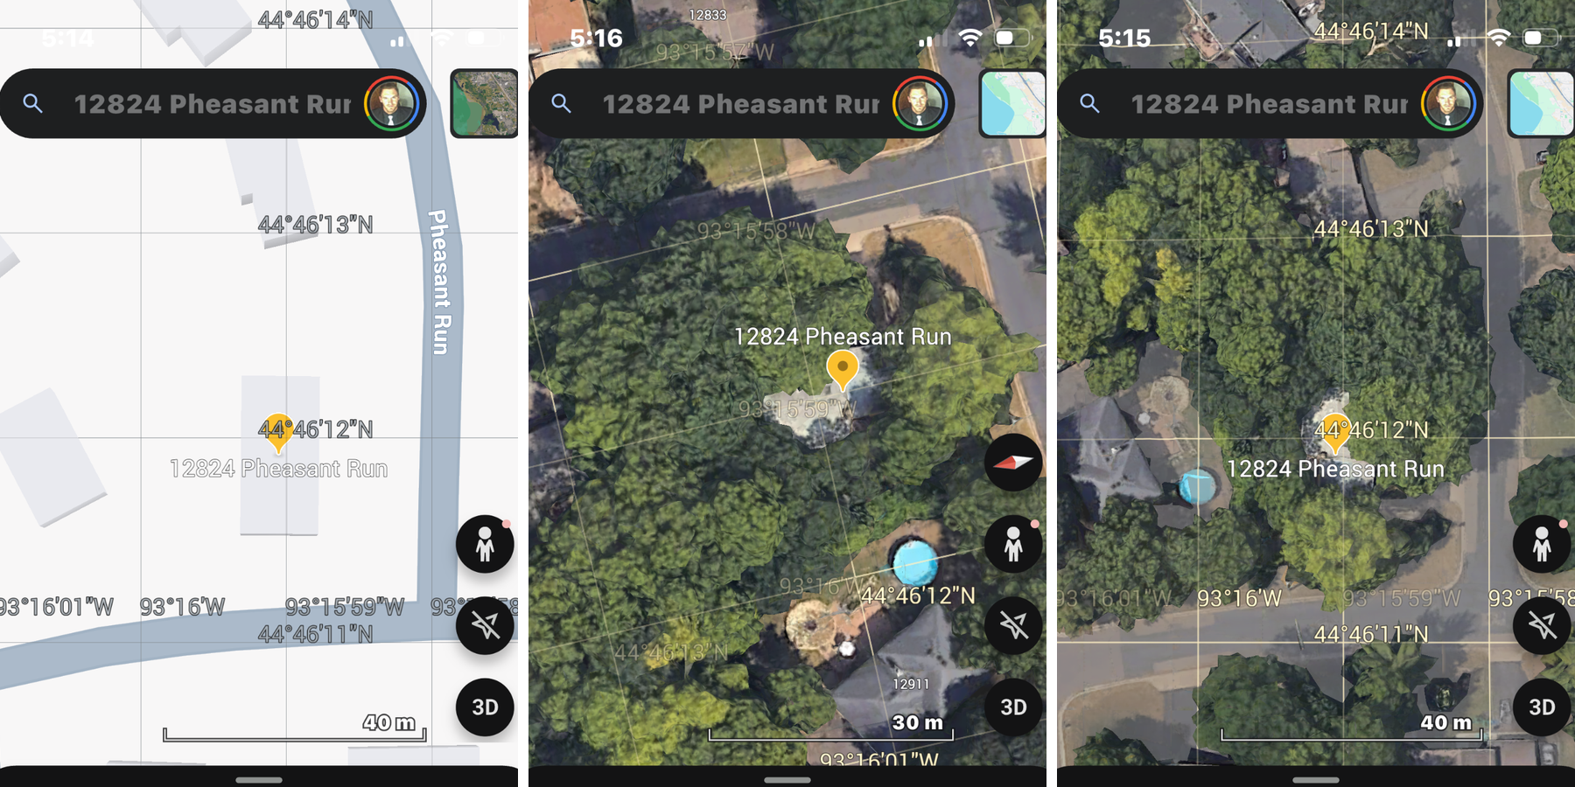

Exhibit B: Sustenance
Land of substance showing vegetable gardens and flag

Picture of your garden and flag
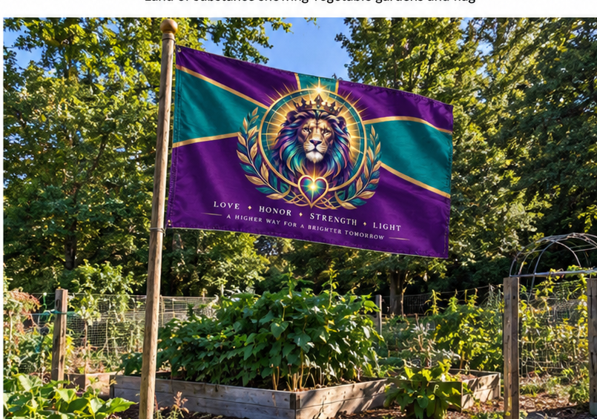

Exhibit C: Compensation Schedule CS-DOB-06/03/1991-ZK-01 for Crown and Company Agents
For services rendered, tasks performed, and material supplied applying to all individuals and entities.
Eﬀective from: 09/07/2026

For any unwarranted unlawful solicited/unsolicited goods and services and/or interference in Our private matters and/or commercial affairs or any individual interfering with our freedom, physical integrity, psychological wellbeing, on our private property will be held personally liable for the following charges:

- Unauthorised use of any of my copy righted trade names: $1,000,000.00 per use
- Accounting/book keeping/invoicing: $10,000 Per hour processing accounts and administration (min charge 4 hours)
- Court appearance: $500,000 Per hour or part thereof.
- Unlawful detention/enslavery $500,000 Per hour or part thereof.
- Kidnapping/False Imprisonment $500,000 Per hour or part thereof.
- Obtaining or causing loss/harm by deception $1,000,000 Per item
- Robbery/demand with intent to steal/harm $1,000,000 Per item
- Use physical force towards me/my property $1,000,000 Per occurrence
- Threats of harm to me or my property $500,000 Per occurrence
- Unlawful confiscation of personal property double replacement value of item plus 5% interest per week until returned.
- Distress and mental anguish $1,000,000 per event for every man and (wo)man, boy or girl
- Extracting a signature under duress, $500,000 per event
to force a contract
- Entry my property without my permission $500,000 per event and per property + per dwelling + $20,000 per metre travelled per living man plus $100,000 per photo taken plus $100,000 per second for time per living person being on my property or for any type of surveillance
- Document preparation $10,000 Per hour/page whichever is higher
- Meetings/Phone use/Research $10,000 Per hour
- Automobile use $100 Per kilometre
- Stationary $100 Per item
- Any type of harm to me or breach of my rights $150,000,000.00 per event
- Harm or Removal of any living (wo)man or animal or plant off my property $1,000,000.00 per day/event per living item.
*Fees are subject to change without notice. Fees to be charged in the currency of my choosing to the gold standard so have option of taking gold or asset valued to same amount. Upon breach of duly delivered personal liability notice or rescinded offers to contract.

Notice:
Forcing or compelling a living sentient being’s unpaid or voluntary performance/servitude or exercising ownership direction or control over a living sentient being is a criminal oﬀence that carries terms of imprisonment. Causing or forcing a living sentient being to enter or engage in debt bondage (involuntary forced payment) is a criminal oﬀence that carries terms of imprisonment. Slavery charges are imprisonment up to 7 years, fraud charges are from 3 to 30 years with one million dollars charge per fraudulent activity. Entry into property includes opening or entering any access way that is on my property that includes doors, windows, gates and entrance ways and any type of surveillance on or into or above my property.

All Absolute Rights Reserved Without Prejudice

